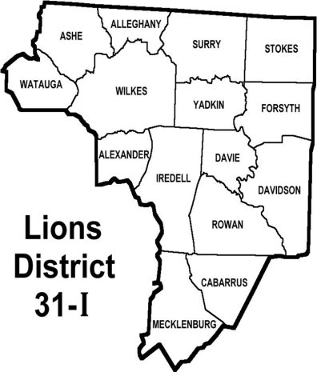
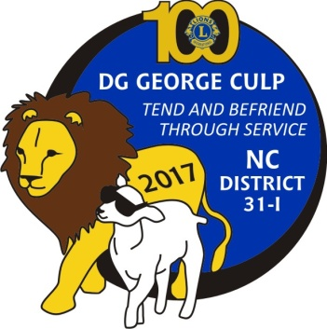
All Club and District Officers of
District 31-I
Are requested to
Attend Oct 14th Cabinet Meeting
Meeting Time: 10:00AM
Lunch: 12:00 Noon
Location: Pilot Lions Club Den
4434 Old Hwy 29, South,
Thomasville, NC (right beside of
Pilot Elementary School, business 85 South)
Menu: BBQ, Slaw, Fries, Bread, Drinks and Deserts
Cost: $10.00.
All proceeds will be given to the District Brighter Visions fund.

Meal Registration

Name ___________________________________________________

Name ___________________________________________________

Name ___________________________________________________

Name ___________________________________________________

Name ___________________________________________________

Name ___________________________________________________

Name ___________________________________________________

Please make checks payable to: District 31-I Lions
Number Amount Enclosed

Saturday Installation Dinner @$10.00 _______________ _______________

Return by Oct 7, 2017

Mail registration to: Lion Ron Staley
7935 Altacrest Drive
Concord, NC 28027

